Tian Qiu

00265 35063

MA366 Lab 09

1.

2. 

3

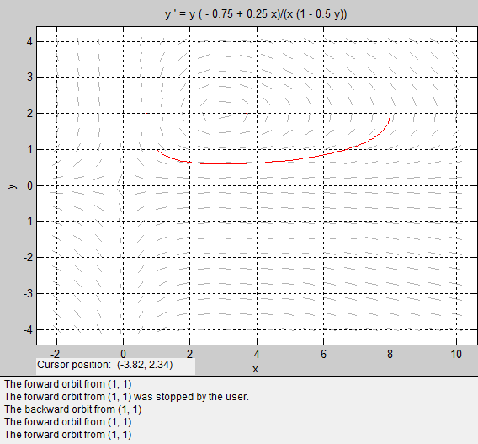

5. y= @ (t) t/exp(0.5\*t); fplot (y/ exp(0.5 \* y) , [1 1.5]);





6. 

7.



9. 